**Microsoft Teams**

**Features:-**

* Chat
* Teams & Channel
* Personal Callender
* Micro Planner
* Team or Private Chat in real time
* Video Chat / Channel meet
* Share a file with a colleague
* Set up a meeting or live event
* Join a meeting or a live event

**Communication :**

* Synchronous
* Nuanced conversation
* Interval communication
* Hub for team apns
* A group of people work together with their contents and apps
* Can be private or public ( upto 10,000 members )
* Can include external members.

**Channel:**

* Used to organize team’s work
* Includes file sharing
* Open to entire team or private people
* External channel by adding aps
* Announcements / team wide discussion
* Direct meeting button
* Multiple texting at a time
* Filters
* Pinned chats
* New chat adding
* Send personal invite message without leaving meeting
* Can take to specific conversion if they are not in teams

**Inbox:**

* Missed activities
* Mentions : personal , channel , team
* Chat message
* Followed channels
* Status notifications for people you follow

Team Member Types :- Owner , members, guests

* Owners :
  + Add/remove members
  + Change settings
  + Set team permissions
  + Edit or delete team
  + Other admin tasks
* Members:
  + Participate in conversations
  + Add apps in channels
  + Join public teams
  + Create new teams or channel
  + Share chat file or channel file
* Guests:
  + Same as members
  + Can’t share chat files

**Calender:**

* Shared calenders from outlook (not teams)
* Event , attende
* Day , date , time , duration , repetation , location , details
* Automatic added to outlook

Insights of analytics with graphs.

Plans :

--- They have two plans one is Home(personal) use other one is business use

Home Plans:

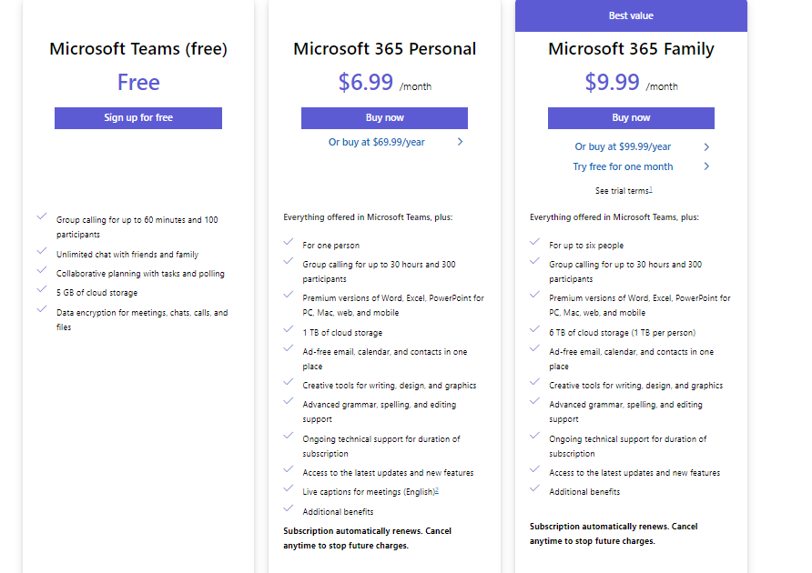

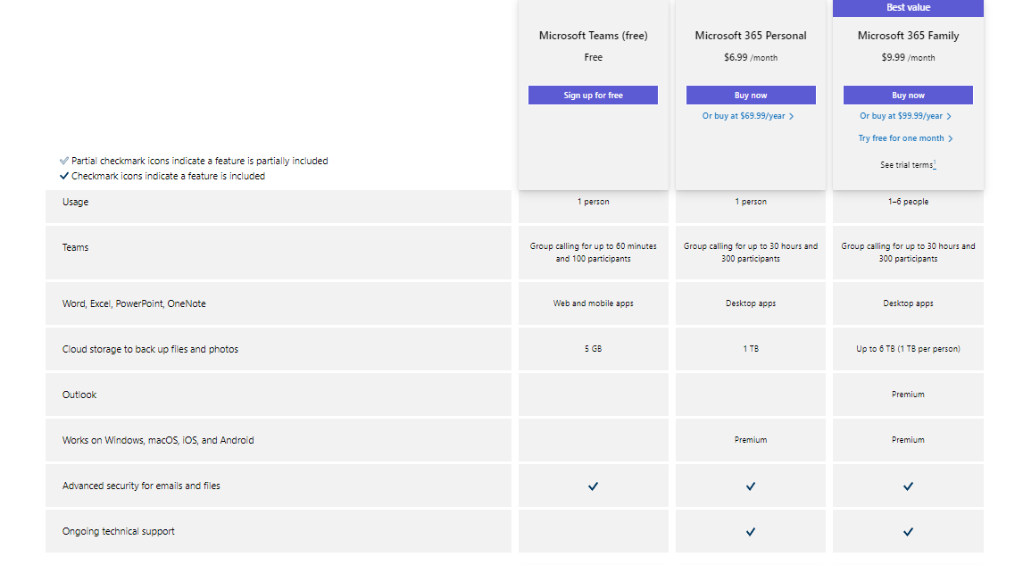

Business Plans:

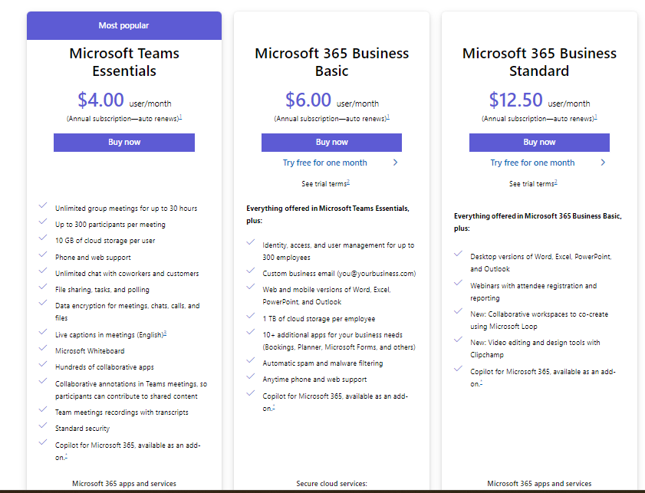

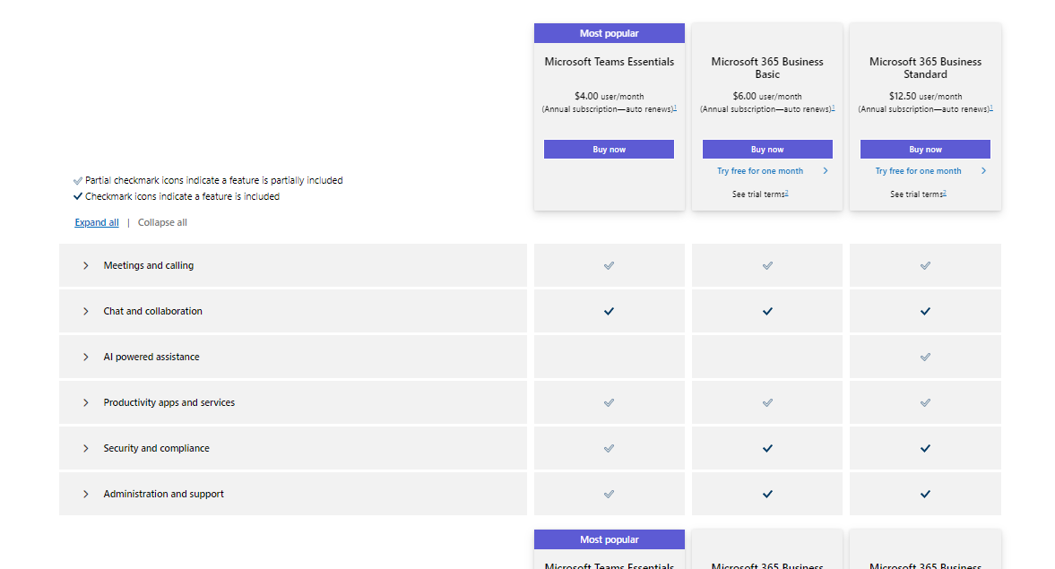

**1. Define the Requirements**

Core Features-

- User authentication and management

- Real-time messaging

- Audio and video conferencing

- File sharing and storage

- Team and channel creation

- Task and project management

- Integration with third-party apps

**2. Design the Architecture**

Frontend:

- Choose a framework/library (React ,Vue.js)

- Design the user interface (UI) and user experience (UX)

Backend:

- Choose a backend framework (Node.js with Express)

- Set up a database (MySQL /MongoDB)

Real-Time Communication:

- WebSockets for real-time messaging (Socket.io for Node.js)

- WebRTC for audio and video conferencing

File Storage:

- Cloud storage solutions (Amazon S3, Google Cloud Storage, Azure Blob Storage)

Authentication:

- OAuth 2.0, JWT for authentication and authorization

**3. Develop the Frontend**

UI/UX Design:

- Create wireframes and mockups

- Design user-friendly and responsive interfaces

Frontend Development:

- Set up the project with chosen frontend framework

- Implement authentication flows

- Develop components for messaging, file sharing, video calls, etc.

- Ensure responsiveness and accessibility

**4. Develop the Backend**

API Design:

- Define RESTful or GraphQL API endpoints

Backend Development:

- Set up the backend framework

- Implement user authentication and authorization

- Develop APIs for messaging, file handling, team management, etc.

- Integrate with real-time communication services

**5. Real-Time Communication**

Messaging:

- Set up WebSocket connections for real-time messaging

Audio/Video Conferencing:

- Use WebRTC for peer-to-peer audio and video communication

- Implement signaling server for WebRTC (using libraries like SimpleWebRTC, PeerJS)

**6. File Storage and Management**

Set Up Cloud Storage:

- Configure cloud storage services for file uploads and downloads

Backend Integration:

- Implement APIs for file upload, download, and management

- Handle file metadata and permissions

**7. Testing**

Unit Testing:

- Write tests for individual components and functions

Integration Testing:

- Test the interaction between different parts of the application

End-to-End Testing:

- Use tools like Selenium, Cypress to test user flows

Performance Testing:

- Ensure the application can handle high loads and stress conditions

**8. Deployment**

Set Up CI/CD Pipeline:

- Use tools like Jenkins, GitHub Actions, GitLab CI/CD for continuous integration and deployment

Deploy Backend:

- Use cloud services like AWS, Google Cloud, Azure

- Set up Docker containers for microservices architecture

Deploy Frontend:

- Host static files on services like Netlify, Vercel, or AWS S3

Database:

- Use managed database services for production environments

**9. Monitoring and Maintenance**

Monitoring:

- Implement monitoring tools like Prometheus, Grafana

- Use logging services like ELK Stack (Elasticsearch, Logstash, Kibana), Splunk

Security:

- Regularly update dependencies

- Implement security best practices

- Conduct regular security audits

Feedback and Iteration:

- Collect user feedback

- Continuously improve features and fix bugs

**10. Documentation**

User Documentation:

- Create user guides and tutorials

Developer Documentation:

- Document APIs, architecture, and development processes

**Tools and Technologies Overview**

- Frontend: React, Vue.js, CSS, HTML

- Backend: Node.js, Express

- Database: MySQL / MongoDB

- Real-Time: WebSockets, WebRTC, Socket.io

- File Storage: AWS S3/ Google Cloud Storage /Azure Blob Storage

- CI/CD: Jenkins, GitHub Actions, GitLab CI/CD

- Monitoring: Prometheus, Grafana, ELK Stack

**Learning Resources:**

**Frontend**

* **React**: A JavaScript library for building user interfaces.
  + **Documentation**: React Docs
* **Vue.js**: The Progressive JavaScript Framework.
  + **Documentation**: Vue.js Docs

**Backend**

* **Node.js with Express**: A JavaScript runtime built on Chrome's V8 JavaScript engine.
  + **Documentation**: Node.js Docs
  + **Express Documentation**: [Express Docs](https://expressjs.com/)

**Database**

* **MongoDB**: A document database with the scalability and flexibility.
  + **Documentation**: [MongoDB Docs](https://docs.mongodb.com/)

**Real-Time Communication**

* **Socket.io**: Enables real-time, bidirectional, and event-based communication.
  + **Documentation**: Socket.io Docs
* **WebRTC**: A free, open-source project that provides web browsers and mobile applications with real-time communication.
  + **Documentation**: WebRTC Docs

**Cloud Storage**

* **AWS S3**: Object storage service that offers industry-leading scalability, data availability, security, and performance.
  + **Documentation**: [AWS S3 Docs](https://docs.aws.amazon.com/s3/index.html)
* **Google Cloud Storage**: Unified object storage for developers and enterprises.
  + **Documentation**: Google Cloud Storage Docs
* **Azure Blob Storage**: Microsoft's object storage solution for the cloud.
  + **Documentation**: [Azure Blob Storage Docs](https://docs.microsoft.com/en-us/azure/storage/blobs/)

**Learning and Implementation Resources**

1. **Courses and Tutorials**
   * **Youtube**
2. **Communities and Forums**
   * **Stack Overflow**: For asking specific questions and finding solutions.
   * **Reddit**: Subreddits like r/webdev, r/learnprogramming.
   * **GitHub**: Explore open-source projects and contribute to them.
3. **Official Documentation**
   * **React**: React Docs
   * **Node.js**: Node.js Docs
   * **WebRTC**: WebRTC Docs
4. **Blogs and Articles**
   * **Medium**: Articles on software development and best practices.
   * **Dev.to**: Community of developers sharing insights and tutorials.